IE 575 Homework 8

Eric Smith

2025-07-20

1.1 Explore the dataset
data <- read_excel("default_of_credit_card_clients.xlsx")
## New names:
## • `` -> `...1`
# Display the first few rows of the dataset
head(data)
## # A tibble: 6 × 25
## ...1 X1 X2 X3 X4 X5 X6 X7 X8 X9 X10 X11 X12
## <chr> <chr> <chr> <chr> <chr> <chr> <chr> <chr> <chr> <chr> <chr> <chr> <chr>
## 1 ID LIMIT… SEX EDUC… MARR… AGE PAY_0 PAY_2 PAY_3 PAY_4 PAY_5 PAY_6 BILL…
## 2 1 20000 2 2 1 24 2 2 -1 -1 -2 -2 3913
## 3 2 120000 2 2 2 26 -1 2 0 0 0 2 2682
## 4 3 90000 2 2 2 34 0 0 0 0 0 0 29239
## 5 4 50000 2 2 1 37 0 0 0 0 0 0 46990
## 6 5 50000 1 2 1 57 -1 0 -1 0 0 0 8617
## # ℹ 12 more variables: X13 <chr>, X14 <chr>, X15 <chr>, X16 <chr>, X17 <chr>,
## # X18 <chr>, X19 <chr>, X20 <chr>, X21 <chr>, X22 <chr>, X23 <chr>, Y <chr>
#Display structure
str(data)
## tibble [30,001 × 25] (S3: tbl_df/tbl/data.frame)
## $ ...1: chr [1:30001] "ID" "1" "2" "3" ...
## $ X1 : chr [1:30001] "LIMIT_BAL" "20000" "120000" "90000" ...
## $ X2 : chr [1:30001] "SEX" "2" "2" "2" ...
## $ X3 : chr [1:30001] "EDUCATION" "2" "2" "2" ...
## $ X4 : chr [1:30001] "MARRIAGE" "1" "2" "2" ...
## $ X5 : chr [1:30001] "AGE" "24" "26" "34" ...
## $ X6 : chr [1:30001] "PAY_0" "2" "-1" "0" ...
## $ X7 : chr [1:30001] "PAY_2" "2" "2" "0" ...
## $ X8 : chr [1:30001] "PAY_3" "-1" "0" "0" ...
## $ X9 : chr [1:30001] "PAY_4" "-1" "0" "0" ...
## $ X10 : chr [1:30001] "PAY_5" "-2" "0" "0" ...
## $ X11 : chr [1:30001] "PAY_6" "-2" "2" "0" ...
## $ X12 : chr [1:30001] "BILL_AMT1" "3913" "2682" "29239" ...
## $ X13 : chr [1:30001] "BILL_AMT2" "3102" "1725" "14027" ...
## $ X14 : chr [1:30001] "BILL_AMT3" "689" "2682" "13559" ...
## $ X15 : chr [1:30001] "BILL_AMT4" "0" "3272" "14331" ...
## $ X16 : chr [1:30001] "BILL_AMT5" "0" "3455" "14948" ...
## $ X17 : chr [1:30001] "BILL_AMT6" "0" "3261" "15549" ...
## $ X18 : chr [1:30001] "PAY_AMT1" "0" "0" "1518" ...
## $ X19 : chr [1:30001] "PAY_AMT2" "689" "1000" "1500" ...
## $ X20 : chr [1:30001] "PAY_AMT3" "0" "1000" "1000" ...
## $ X21 : chr [1:30001] "PAY_AMT4" "0" "1000" "1000" ...
## $ X22 : chr [1:30001] "PAY_AMT5" "0" "0" "1000" ...
## $ X23 : chr [1:30001] "PAY_AMT6" "0" "2000" "5000" ...
## $ Y : chr [1:30001] "default payment next month" "1" "1" "0" ...
# Step 1: Extract the column names from the first row
col_names <- as.character(data[1, -1]) # drop the first column ("ID")

# Step 2: Drop the first row and first column, then set names
data_clean <- data[-1, -1]
names(data_clean) <- col_names

# Step 3: Convert columns to numeric
data_clean <- data_clean %>%
mutate(across(everything(), as.numeric))

# Step 4: Convert response variable to factor with consistent levels
data_clean$`default payment next month` <- factor(data_clean$`default payment next month`, levels = c(0, 1))
# Report NAs per column
na_report <- data_clean %>%
summarise(across(everything(), ~ sum(is.na(.)))) %>%
pivot_longer(cols = everything(),
names_to = "Column",
values_to = "Missing_Values")

# Count duplicates
duplicate_count <- data_clean %>% duplicated() %>% sum()

# Total number of rows with at least one NA
rows_with_na <- sum(!complete.cases(data_clean))
cat("Number of rows with at least one NA:", rows_with_na, "\n")
## Number of rows with at least one NA: 0
# Print duplicate info
cat("Number of duplicate rows:", duplicate_count, "\n")
## Number of duplicate rows: 35
# Reshape to long format for plotting
data_long <- data_clean %>%
pivot_longer(cols = -`default payment next month`, names_to = "Feature", values_to = "Value")

# Plot small multiples (faceted histograms)
ggplot(data_long, aes(x = Value)) +
geom_histogram(bins = 30, fill = "steelblue", color = "white") +
facet_wrap(~ Feature, scales = "free") +
theme_minimal() +
labs(title = "istogram Distributions of All Features")
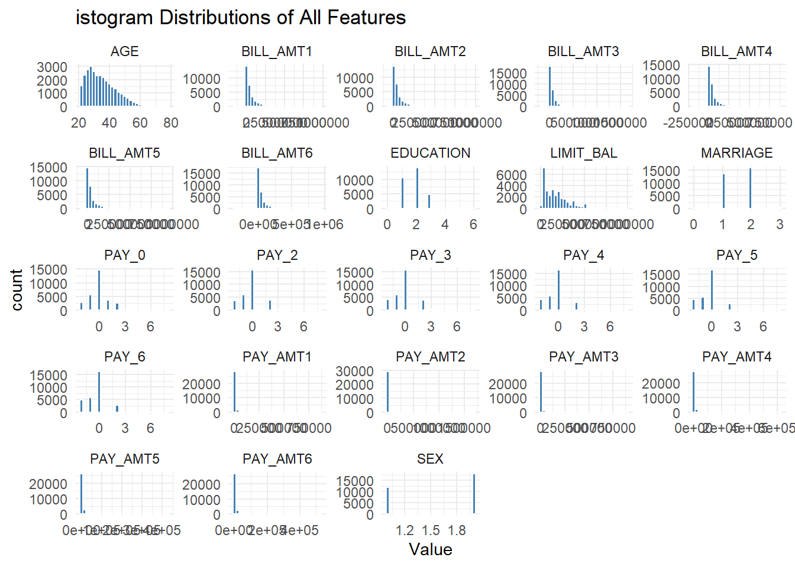
Fig 1. Small Multiples: Histogram Distributions of All Features

Dataset Observations
This dataset has information on 30,000 credit card customers with 23 variables that describe things like age, gender, education, marital status, credit limits, billing amounts, and past payment behavior. The goal is to predict whether someone will default on their payment next month (1 = default, 0 = no default).
When I looked at the data, I saw there were no missing values, but there are 35 duplicate rows that might need to be removed. The first row actually just contains the column names, so that has to be dropped before analysis.
Most customers are in their 20s to 50s as we can see in Fig. 1, and the demographic variables like gender, education, and marriage are mostly straightforward categories. The financial variables, like credit limits and bill amounts, are very skewed—most people have relatively small balances or payments, but a few customers have extremely high values.
The payment history variables show that a lot of people paid on time (coded -1 or 0), but there are also clear cases of late payments. Those delays will probably be strong predictors of default.
So overall, the dataset looks clean and well-structured, but it has a mix of categorical and numeric variables and some very uneven distributions. That means we’ll probably need to scale or normalize the financial data and encode the categories before training a neural network.

1.2 Create a partioned Neural Network Model
# Partition into training and testing sets
set.seed(123)
index <- createDataPartition(data_clean$`default payment next month`, p = 0.8, list = FALSE)
train_data <- data_clean[index, ]
test_data <- data_clean[-index, ]
# Normalize predictors (same of preprocess from Lesson)
normalize <- function(x) { (x - min(x)) / (max(x) - min(x)) }

train_scaled <- train_data %>%
mutate(across(-`default payment next month`, normalize))

test_scaled <- test_data %>%
mutate(across(-`default payment next month`, normalize))

# Reattach target variable with consistent levels
train_scaled$`default payment next month` <- factor(train_data$`default payment next month`, levels = c(0, 1))
test_scaled$`default payment next month` <- factor(test_data$`default payment next month`, levels = c(0, 1))

# Train the neural network
nn_model <- nnet(
`default payment next month` ~ .,
data = train_scaled,
size = 5,
maxit = 500,
decay = 0.01,
trace = FALSE
)
# Predict class
predicted_classes <- predict(nn_model, newdata = test_scaled, type = "class")

# Ensure predicted_classes is a factor with correct levels
predicted_classes <- factor(predicted_classes, levels = c(0, 1))

# Evaluate with confusion matrix
conf_matrix <- confusionMatrix(predicted_classes, test_scaled$`default payment next month`)
print(conf_matrix)
## Confusion Matrix and Statistics
##
## Reference
## Prediction 0 1
## 0 4528 989
## 1 144 338
##
## Accuracy : 0.8111
## 95% CI : (0.801, 0.821)
## No Information Rate : 0.7788
## P-Value [Acc > NIR] : 4.42e-10
##
## Kappa : 0.29
##
## Mcnemar's Test P-Value : < 2.2e-16
##
## Sensitivity : 0.9692
## Specificity : 0.2547
## Pos Pred Value : 0.8207
## Neg Pred Value : 0.7012
## Prevalence : 0.7788
## Detection Rate : 0.7548
## Detection Prevalence : 0.9197
## Balanced Accuracy : 0.6119
##
## 'Positive' Class : 0
##
# Extract performance metrics from confusion matrix
performance_metrics <- data.frame(
Metric = c("Accuracy", "Sensitivity", "Specificity", "Precision", "F1 Score"),
Value = c(
round(unname(conf_matrix$overall["Accuracy"]), 3),
round(unname(conf_matrix$byClass["Sensitivity"]), 3),
round(unname(conf_matrix$byClass["Specificity"]), 3),
round(unname(conf_matrix$byClass["Precision"]), 3),
round(unname(conf_matrix$byClass["F1"]), 3)
),
stringsAsFactors = FALSE
)

# Display nicely with kable (optional)
knitr::kable(performance_metrics, caption = "Table 1. Neural Network Model Performance")
Table 1. Neural Network Model Performance
Metric | Value
Accuracy | 0.811
Sensitivity | 0.969
Specificity | 0.255
Precision | 0.821
F1 Score | 0.889
# Load required package
# install.packages("pROC") # Uncomment if not already installed

# --- Predict probabilities from the neural network ---
# This gives probabilities for the "1" class (default)
prob_predictions <- predict(nn_model, newdata = test_scaled, type = "raw")

# --- Extract true labels as numeric ---
true_labels <- as.numeric(as.character(test_scaled$`default payment next month`))

# --- Compute ROC object and plot ---
roc_obj <- roc(response = true_labels, predictor = prob_predictions)
## Setting levels: control = 0, case = 1
## Warning in roc.default(response = true_labels, predictor = prob_predictions):
## Deprecated use a matrix as predictor. Unexpected results may be produced,
## please pass a numeric vector.
## Setting direction: controls < cases
# Plot ROC curve
plot(
roc_obj,
col = "darkblue",
lwd = 2,
main = "ROC Curve for Neural Network Model",
xlab = "1 - Specificity",
ylab = "Sensitivity"
)
abline(a = 0, b = 1, lty = 2, col = "gray") # Diagonal reference line
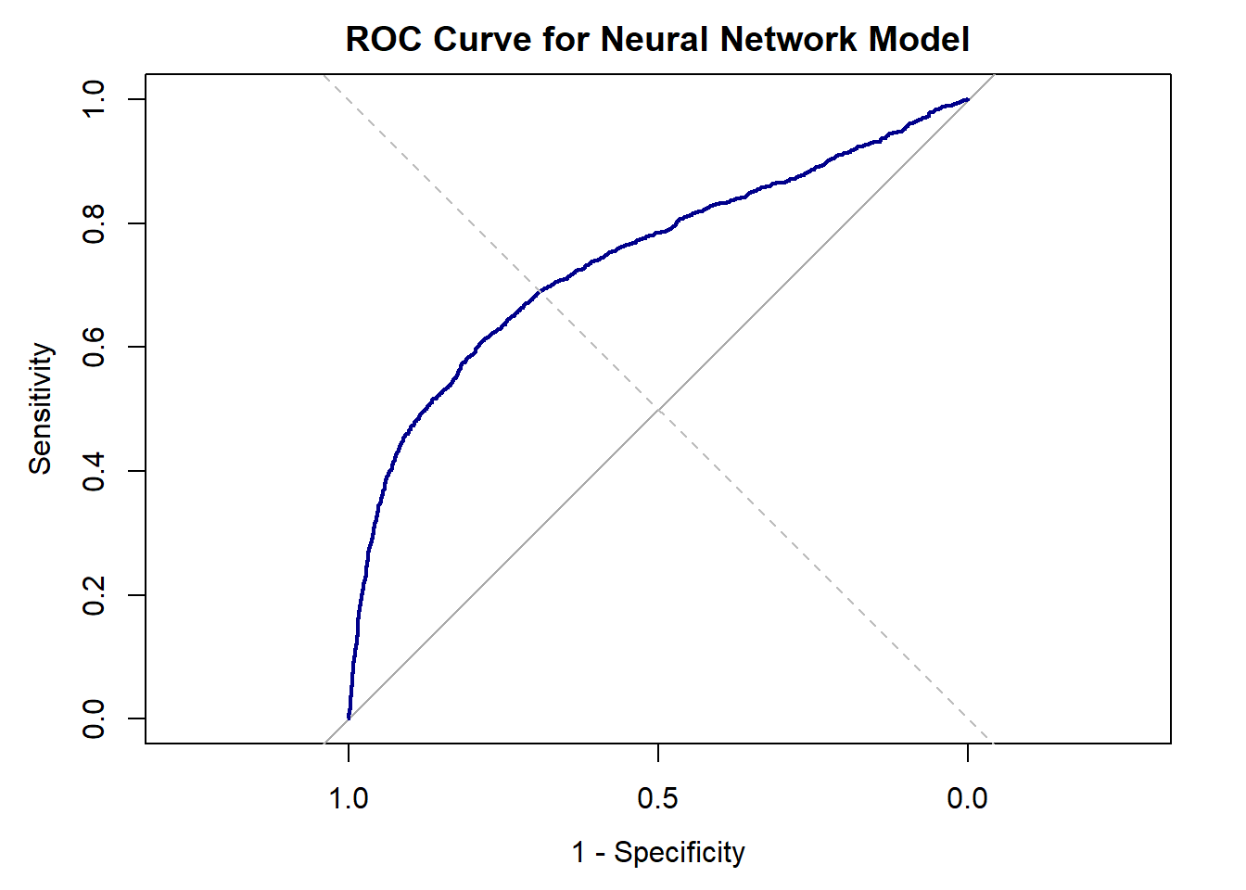
Fig 2. ROC curve
# --- Print AUC ---
auc_value <- auc(roc_obj)
print(paste("AUC:", round(auc_value, 3)))
## [1] "AUC: 0.741"
Neural Network Observations
The neural network ended up with about 81% accuracy. The AUC is 0.74, showing it is picking up some patterns in the data reasonably well.
Looking closer, the model is really good at spotting people who won’t default (sensitivity is high at 97%), but it’s not great at catching actual defaulters—the specificity is only 25%. The precision is about 82%, meaning that most of the time when it says someone won’t default, it’s correct.
The F1 score is 0.89, which is a way of combining precision and recall into one number. It tells us the model does a decent job of balancing being correct with not missing too many cases, at least for the majority class.
Overall, the model works reasonably well, but it definitely favors the “no default” outcome, which means it’s not very good at actually finding the people who are at risk.

2.1 Identify the variable importance
# --- 1. Garson Variable Importance ---

# Extract Garson importance values
importance_vals <- garson(nn_model, bar_plot = FALSE)
importance_vec <- unlist(importance_vals)

# Extract actual variable names used in the model
actual_vars <- attr(nn_model$terms, "term.labels")

# Sanity check to ensure alignment
if (length(actual_vars) == length(importance_vec)) {
importance_df <- data.frame(
Variable = actual_vars,
GarsonImportance = round(importance_vec, 3)
)
} else {
warning("Variable name count mismatch in Garson output.")
importance_df <- data.frame(
Variable = names(importance_vec),
GarsonImportance = round(importance_vec, 3)
)
}

# --- 2. Correlation with Target ---

# Ensure the target is numeric
cor_vals <- cor(
data_clean %>% select(-`default payment next month`),
as.numeric(as.character(data_clean$`default payment next month`))
)

cor_df <- data.frame(
Variable = rownames(cor_vals),
Correlation = round(cor_vals[, 1], 3)
)

# --- 3. Merge and Display ---

# Merge by variable name
var_compare_df <- full_join(importance_df, cor_df, by = "Variable") %>%
arrange(desc(GarsonImportance))

# Display
knitr::kable(var_compare_df, caption = "Table 2. Variable Importance: Garson Method and Correlation with Default")
Table 2. Variable Importance: Garson Method and Correlation with Default
Variable | GarsonImportance | Correlation
PAY_0 | 0.135 | 0.325
PAY_AMT2 | 0.110 | -0.059
PAY_AMT4 | 0.076 | -0.057
BILL_AMT1 | 0.066 | -0.020
BILL_AMT2 | 0.066 | -0.014
PAY_AMT5 | 0.064 | -0.055
PAY_AMT3 | 0.059 | -0.056
BILL_AMT5 | 0.052 | -0.007
PAY_AMT1 | 0.051 | -0.073
BILL_AMT3 | 0.040 | -0.014
PAY_4 | 0.034 | 0.217
LIMIT_BAL | 0.031 | -0.154
PAY_5 | 0.030 | 0.204
PAY_6 | 0.030 | 0.187
PAY_2 | 0.025 | 0.264
BILL_AMT4 | 0.025 | -0.010
PAY_3 | 0.024 | 0.235
BILL_AMT6 | 0.024 | -0.005
PAY_AMT6 | 0.024 | -0.053
EDUCATION | 0.019 | 0.028
AGE | 0.007 | 0.014
MARRIAGE | 0.004 | -0.024
SEX | 0.003 | -0.040
# Garson Importance Plot
ggplot(var_compare_df, aes(x = reorder(Variable, GarsonImportance), y = GarsonImportance)) +
geom_bar(stat = "identity", fill = "steelblue") +
coord_flip() +
labs(
title = "Variable Importance by Garson Method",
x = "Variable",
y = "Garson Importance"
) +
theme_minimal()
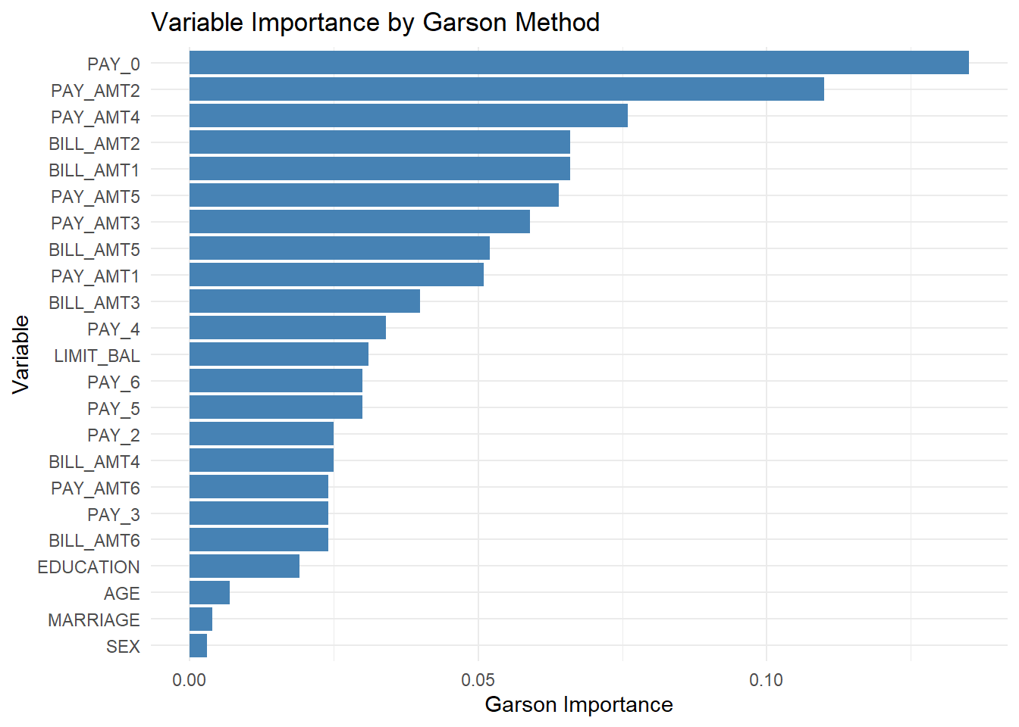
Fig 3. Variable Importance using Garson Method

# Correlation Plot
ggplot(var_compare_df, aes(x = reorder(Variable, abs(Correlation)), y = Correlation)) +
geom_bar(stat = "identity", fill = "darkorange") +
coord_flip() +
labs(
title = "Correlation of Variables with Default Outcome",
x = "Variable",
y = "Correlation"
) +
theme_minimal()
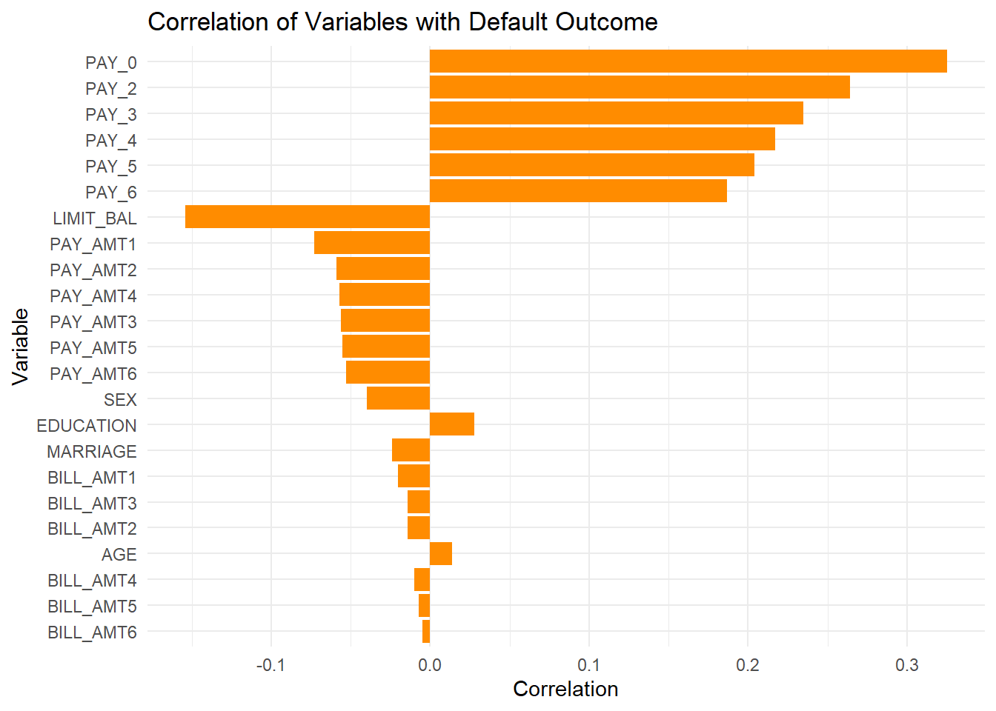
Fig 4. Correlation of Variables from model outcome

Variable Importance Observations
We looked at which variables were most important using two approaches. Garson’s method comes from the neural network itself—it looks at how much each input contributed to the predictions based on the weights in the model. Correlation is much simpler and just measures how directly each variable relates to the default outcome on its own.
Both methods tell the same basic story. PAY_0, the most recent payment status, is by far the most important factor. Other payment history variables like PAY_2, PAY_3, and PAY_4 also rank high, which makes sense since late payments directly relate to default risk. Some recent payment amounts and bill amounts have moderate importance, but they’re not as strong as the payment history.
On the other end, demographic variables like age, marriage, education, and gender barely matter. Who the person is doesn’t seem to influence default nearly as much as their actual payment behavior.
So overall, the model is driven mainly by recent repayment history, with financial amounts playing a smaller role and demographics having almost no impact.

3.1 Insights and credit card company marketing strategy
From the modeling, a few clear insights stand out. Before training, I scaled all the predictor variables to a 0–1 range so everything was on the same scale. This keeps big numbers like credit limits from overshadowing smaller ones like age and makes it easier for the neural network to learn. The neural network performs reasonably well, with about 81% accuracy and an AUC of 0.74, so it’s definitely picking up useful patterns. It’s very good at identifying customers who won’t default, but it struggles more to catch the ones who actually will. Looking at what drives the predictions, the most important factor is recent payment history—especially PAY_0, the most recent payment status. Other recent repayment statuses and some payment amounts also matter, but demographic information like age, education, or gender has almost no real influence on whether someone defaults.
If I were the credit card company marketing manager, I’d focus on behavioral signals rather than demographics. Instead of targeting customers broadly based on who they are, I’d use their recent repayment behavior to guide our strategy. For example, customers showing early signs of delayed payments could be offered reminders, flexible payment plans, or small incentives to stay on track before they fall too far behind. On the flip side, customers who consistently pay on time could be rewarded with loyalty perks or credit limit increases to strengthen retention.
The main takeaway is that what people do with their accounts now matters far more than who they are, so marketing efforts should prioritize timely engagement with customers who are trending toward risk. Early intervention could reduce defaults, while well-timed rewards could keep reliable customers engaged and loyal.
Key observations:
- Default risk is driven mainly by recent repayment history, especially the most recent month (PAY_0).
- Other repayment history variables (PAY_2, PAY_3, etc.) also matter, while demographics like age, gender, and education have very little influence.
- The model is better at identifying safe customers than catching those who will default.
Action items based on the model:
- Segment customers by recent repayment history, since this is the strongest predictor of default.
- Prioritize monitoring the most recent payment behavior (PAY_0) to flag potential risk earlier.
- Use repayment history patterns (e.g., consistent late payments) to guide which customers should receive closer follow-up or tailored communication.
- Avoid relying on demographic information for targeting, since it adds little value in predicting default.

Appendix: Full Code

---
title: "IE 575 Homework 8"
author: "Eric Smith"
date: "`r Sys.Date()`"
output: html_document
---

```{r setup, include=FALSE}
knitr::opts_chunk$set(echo = TRUE)
```

```{r, include=FALSE}

# Load necessary libraries
library(dplyr)
library(tibble)
library(nnet)
library(caret)
library(pROC)
library(NeuralNetTools)
library(ggplot2)
library(readxl)
library(tidyr)

# Set working directory
setwd("D:/GradSchool/IE575/Lesson10")

```

# 1.1 Explore the dataset

```{r}

data <- read_excel("default_of_credit_card_clients.xlsx")
# Display the first few rows of the dataset
head(data)

#Display structure
str(data)

```

```{r}

# Step 1: Extract the column names from the first row
col_names <- as.character(data[1, -1]) # drop the first column ("ID")

# Step 2: Drop the first row and first column, then set names
data_clean <- data[-1, -1]
names(data_clean) <- col_names

# Step 3: Convert columns to numeric
data_clean <- data_clean %>%
mutate(across(everything(), as.numeric))

# Step 4: Convert response variable to factor with consistent levels
data_clean$`default payment next month` <- factor(data_clean$`default payment next month`, levels = c(0, 1))

```

```{r}

# Report NAs per column
na_report <- data_clean %>%
summarise(across(everything(), ~ sum(is.na(.)))) %>%
pivot_longer(cols = everything(),
names_to = "Column",
values_to = "Missing_Values")

# Count duplicates
duplicate_count <- data_clean %>% duplicated() %>% sum()

# Total number of rows with at least one NA
rows_with_na <- sum(!complete.cases(data_clean))
cat("Number of rows with at least one NA:", rows_with_na, "\n")

# Print duplicate info
cat("Number of duplicate rows:", duplicate_count, "\n")

```

```{r}

# Reshape to long format for plotting
data_long <- data_clean %>%
pivot_longer(cols = -`default payment next month`, names_to = "Feature", values_to = "Value")

# Plot small multiples (faceted histograms)
ggplot(data_long, aes(x = Value)) +
geom_histogram(bins = 30, fill = "steelblue", color = "white") +
facet_wrap(~ Feature, scales = "free") +
theme_minimal() +
labs(title = "istogram Distributions of All Features")

```

<center>*Fig 1. Small Multiples: Histogram Distributions of All Features*</center>

> **Dataset Observations**
>
> This dataset has information on 30,000 credit card customers with 23 variables that describe things like age, gender, education, marital status, credit limits, billing amounts, and past payment behavior. The goal is to predict whether someone will default on their payment next month (1 = default, 0 = no default).
>
> When I looked at the data, I saw there were no missing values, but there are 35 duplicate rows that might need to be removed. The first row actually just contains the column names, so that has to be dropped before analysis.
>
> Most customers are in their 20s to 50s as we can see in Fig. 1, and the demographic variables like gender, education, and marriage are mostly straightforward categories. The financial variables, like credit limits and bill amounts, are very skewed—most people have relatively small balances or payments, but a few customers have extremely high values.
>
> The payment history variables show that a lot of people paid on time (coded -1 or 0), but there are also clear cases of late payments. Those delays will probably be strong predictors of default.
>
> So overall, the dataset looks clean and well-structured, but it has a mix of categorical and numeric variables and some very uneven distributions. That means we’ll probably need to scale or normalize the financial data and encode the categories before training a neural network.

# 1.2 Create a partioned Neural Network Model

```{r}

# Partition into training and testing sets
set.seed(123)
index <- createDataPartition(data_clean$`default payment next month`, p = 0.8, list = FALSE)
train_data <- data_clean[index, ]
test_data <- data_clean[-index, ]

```

```{r}
# Normalize predictors (same of preprocess from Lesson)
normalize <- function(x) { (x - min(x)) / (max(x) - min(x)) }

train_scaled <- train_data %>%
mutate(across(-`default payment next month`, normalize))

test_scaled <- test_data %>%
mutate(across(-`default payment next month`, normalize))

# Reattach target variable with consistent levels
train_scaled$`default payment next month` <- factor(train_data$`default payment next month`, levels = c(0, 1))
test_scaled$`default payment next month` <- factor(test_data$`default payment next month`, levels = c(0, 1))

# Train the neural network
nn_model <- nnet(
`default payment next month` ~ .,
data = train_scaled,
size = 5,
maxit = 500,
decay = 0.01,
trace = FALSE
)

```

```{r}
# Predict class
predicted_classes <- predict(nn_model, newdata = test_scaled, type = "class")

# Ensure predicted_classes is a factor with correct levels
predicted_classes <- factor(predicted_classes, levels = c(0, 1))

# Evaluate with confusion matrix
conf_matrix <- confusionMatrix(predicted_classes, test_scaled$`default payment next month`)
print(conf_matrix)

```

```{r}

# Extract performance metrics from confusion matrix
performance_metrics <- data.frame(
Metric = c("Accuracy", "Sensitivity", "Specificity", "Precision", "F1 Score"),
Value = c(
round(unname(conf_matrix$overall["Accuracy"]), 3),
round(unname(conf_matrix$byClass["Sensitivity"]), 3),
round(unname(conf_matrix$byClass["Specificity"]), 3),
round(unname(conf_matrix$byClass["Precision"]), 3),
round(unname(conf_matrix$byClass["F1"]), 3)
),
stringsAsFactors = FALSE
)

# Display nicely with kable (optional)
knitr::kable(performance_metrics, caption = "Table 1. Neural Network Model Performance")

```

```{r}

# Load required package
# install.packages("pROC") # Uncomment if not already installed

# --- Predict probabilities from the neural network ---
# This gives probabilities for the "1" class (default)
prob_predictions <- predict(nn_model, newdata = test_scaled, type = "raw")

# --- Extract true labels as numeric ---
true_labels <- as.numeric(as.character(test_scaled$`default payment next month`))

# --- Compute ROC object and plot ---
roc_obj <- roc(response = true_labels, predictor = prob_predictions)

# Plot ROC curve
plot(
roc_obj,
col = "darkblue",
lwd = 2,
main = "ROC Curve for Neural Network Model",
xlab = "1 - Specificity",
ylab = "Sensitivity"
)
abline(a = 0, b = 1, lty = 2, col = "gray") # Diagonal reference line
```

<center>*Fig 2. ROC curve*</center>

```{r}

# --- Print AUC ---
auc_value <- auc(roc_obj)
print(paste("AUC:", round(auc_value, 3)))

```

> **Neural Network Observations**
>
> The neural network ended up with about 81% accuracy. The AUC is 0.74, showing it is picking up some patterns in the data reasonably well.
>
> Looking closer, the model is really good at spotting people who won’t default (sensitivity is high at 97%), but it’s not great at catching actual defaulters—the specificity is only 25%. The precision is about 82%, meaning that most of the time when it says someone won’t default, it’s correct.
>
> The F1 score is 0.89, which is a way of combining precision and recall into one number. It tells us the model does a decent job of balancing being correct with not missing too many cases, at least for the majority class.
>
> Overall, the model works reasonably well, but it definitely favors the “no default” outcome, which means it’s not very good at actually finding the people who are at risk.

# 2.1 Identify the variable importance

```{r}

# --- 1. Garson Variable Importance ---

# Extract Garson importance values
importance_vals <- garson(nn_model, bar_plot = FALSE)
importance_vec <- unlist(importance_vals)

# Extract actual variable names used in the model
actual_vars <- attr(nn_model$terms, "term.labels")

# Sanity check to ensure alignment
if (length(actual_vars) == length(importance_vec)) {
importance_df <- data.frame(
Variable = actual_vars,
GarsonImportance = round(importance_vec, 3)
)
} else {
warning("Variable name count mismatch in Garson output.")
importance_df <- data.frame(
Variable = names(importance_vec),
GarsonImportance = round(importance_vec, 3)
)
}

# --- 2. Correlation with Target ---

# Ensure the target is numeric
cor_vals <- cor(
data_clean %>% select(-`default payment next month`),
as.numeric(as.character(data_clean$`default payment next month`))
)

cor_df <- data.frame(
Variable = rownames(cor_vals),
Correlation = round(cor_vals[, 1], 3)
)

# --- 3. Merge and Display ---

# Merge by variable name
var_compare_df <- full_join(importance_df, cor_df, by = "Variable") %>%
arrange(desc(GarsonImportance))

# Display
knitr::kable(var_compare_df, caption = "Table 2. Variable Importance: Garson Method and Correlation with Default")

```

```{r}

# Garson Importance Plot
ggplot(var_compare_df, aes(x = reorder(Variable, GarsonImportance), y = GarsonImportance)) +
geom_bar(stat = "identity", fill = "steelblue") +
coord_flip() +
labs(
title = "Variable Importance by Garson Method",
x = "Variable",
y = "Garson Importance"
) +
theme_minimal()

```

<center>*Fig 3. Variable Importance using Garson Method*</center>

``` {r}

# Correlation Plot
ggplot(var_compare_df, aes(x = reorder(Variable, abs(Correlation)), y = Correlation)) +
geom_bar(stat = "identity", fill = "darkorange") +
coord_flip() +
labs(
title = "Correlation of Variables with Default Outcome",
x = "Variable",
y = "Correlation"
) +
theme_minimal()

```

<center>*Fig 4. Correlation of Variables from model outcome*</center>

> **Variable Importance Observations**
>
> We looked at which variables were most important using two approaches. Garson’s method comes from the neural network itself—it looks at how much each input contributed to the predictions based on the weights in the model. Correlation is much simpler and just measures how directly each variable relates to the default outcome on its own.
>
> Both methods tell the same basic story. PAY_0, the most recent payment status, is by far the most important factor. Other payment history variables like PAY_2, PAY_3, and PAY_4 also rank high, which makes sense since late payments directly relate to default risk. Some recent payment amounts and bill amounts have moderate importance, but they’re not as strong as the payment history.
>
> On the other end, demographic variables like age, marriage, education, and gender barely matter. Who the person is doesn’t seem to influence default nearly as much as their actual payment behavior.
>
> So overall, the model is driven mainly by recent repayment history, with financial amounts playing a smaller role and demographics having almost no impact.

# 3.1 Insights and credit card company marketing strategy

> From the modeling, a few clear insights stand out. Before training, I scaled all the predictor variables to a 0–1 range so everything was on the same scale. This keeps big numbers like credit limits from overshadowing smaller ones like age and makes it easier for the neural network to learn. The neural network performs reasonably well, with about 81% accuracy and an AUC of 0.74, so it’s definitely picking up useful patterns. It’s very good at identifying customers who won’t default, but it struggles more to catch the ones who actually will. Looking at what drives the predictions, the most important factor is recent payment history—especially PAY_0, the most recent payment status. Other recent repayment statuses and some payment amounts also matter, but demographic information like age, education, or gender has almost no real influence on whether someone defaults.
>
> If I were the credit card company marketing manager, I’d focus on behavioral signals rather than demographics. Instead of targeting customers broadly based on who they are, I’d use their recent repayment behavior to guide our strategy. For example, customers showing early signs of delayed payments could be offered reminders, flexible payment plans, or small incentives to stay on track before they fall too far behind. On the flip side, customers who consistently pay on time could be rewarded with loyalty perks or credit limit increases to strengthen retention.
>
> The main takeaway is that what people do with their accounts now matters far more than who they are, so marketing efforts should prioritize timely engagement with customers who are trending toward risk. Early intervention could reduce defaults, while well-timed rewards could keep reliable customers engaged and loyal.
>
> Key observations:
>
> - Default risk is driven mainly by recent repayment history, especially the most recent month (PAY_0).
>
> - Other repayment history variables (PAY_2, PAY_3, etc.) also matter, while demographics like age, gender, and education have very little influence.
>
> - The model is better at identifying safe customers than catching those who will default.
>
> Action items based on the model:
>
> - Segment customers by recent repayment history, since this is the strongest predictor of default.
>
> - Prioritize monitoring the most recent payment behavior (PAY_0) to flag potential risk earlier.
>
> - Use repayment history patterns (e.g., consistent late payments) to guide which customers should receive closer follow-up or tailored communication.
>
> - Avoid relying on demographic information for targeting, since it adds little value in predicting default.

# Appendix

